SOFTWARE DESIGN DOCUMENT

for

The Project Team



and

The Sponsoring Group

Angus-Hamer, Inc.

May 06, 2001

1. INTRODUCTION 1
1.1. Purpose 1
1.2. Scope 1
1.3. Definitions, Acronyms and Abbreviations 1
1.4. References 3
1.5. Overview of Contents of Document 3
2. ARCHITECTURAL DESIGN 4
2.1 Client / Server Hardware Tiers 6
2.2 Client / Server Software Layers 7
3 SYSTEM INTERFACE DESIGN 8
3.2 Application Overview 8
3.3 Window Navigation Diagram 8
3.4 Window Layout 9
3.5 Window Specification 10
3.6 Window Description 10
3.7 Window Mini-Specification 11
3.8 Field Specification 11
4 DATABASE DESIGN 11
5 INTERNAL COMPONENT DESIGN 12
5.15 Add_users_to_ITMS 24
5.15.1 Type 24
6 PERFORMANCE ANALYSIS 25
7 FEASIBILITY AND RESOURCE ESTIMATES 26
8 SOFTWARE REQUIREMENTS TRACEABILITY MATRIX 27
APPENDIX A: ITMS MODULE MAP 28
APPENDIX B: REQUIREMENTS TRACEABILITY MATRIX 29
Appendix C: Data Flow Diagram 30
APPENDIX D: APPROVALS 32

1. INTRODUCTION
This software design document (SDD) is a formal architectural blueprint for the product ValleyData Programming Group is developing for Angus-Hamer, Inc. The functions which constitute the design of the Internet Task Management System (ITMS) are discussed in detail within this document. The layout is structured to help the reader recognize the requirements imposed upon the system and how these requirements are being met.

1.1. Purpose
This document describes all the standards and designs of ITMS to be used by the developers to follow in the implementation phase. The SDD is an important reference not only for developers but also for the testing programmers and editors of documentation. With the help of standards and specifications described here, team members can be more efficient and successful in implementing the product.

1.2. Scope
ITMS is a UNIX compatible application that automates sending emails to different people assigned to do different tasks. This product will help keep track of the assignments made to different employees, as they will get reminders accordingly as long as the task is pending. It considerably reduces the amount of paperwork needed for such tasks. Our goal is to implement this product adhering to the specifications, execution environment, naming standards, coding standards, software architecture, software design, software modules (including both interface and Program Design Language), design analysis, and packaging of Version Viewer provided by SDD. In addition, all requirements documented in the SRS shall be implemented and addressed in the SDD.

1.3. Definitions, Acronyms, and Abbreviations
All acronyms, abbreviations, and technical terms used in this document are arranged in alphabetical order.

AHN | Angus-Hamer, Inc.
BSDI | Berkeley Software Design, Inc. Operating System
CRUD | Create, Read, Update, Delete
HR | Human Resource(s)
ITMS | Internet Task Management System
LDAP | Lightweight Directory Access Protocol
NTP | Network Time Protocol
RDMS | Relational Database Management System
SDD | Software Design Document
SMM | Software Maintenance Manual
SMTP | Simple Mail Transfer Protocol
SPMP | Software Project Management Plan (this document)
SQL | Structured Query Language
SRS | Software Requirements Specification
SSP | Software System Proposal
STD | System Test Document
STR | System Test Report
UM | User Manual
VDPG | ValleyData Programming Group
WBS | Work Breakdown Schedule
Table 1.3.1 - Acronyms and Abbreviations

Baseline | A work product that has been formally reviewed and accepted by the involved parties, to be changed only through formal configuration management procedures.
Group | A collection of Users specialized into a particular division.
Milestone | A scheduled event used to measure progress.
Project Deliverable | A work product that is delivered to the project sponsor.
Protocol | A set of conventions that govern the interaction of processes, devices, and other components within a system.
Task | The smallest unit of work subject to accountability.
Software Requirements Specification | Documentation of the essential requirements  (functions/features/uses, performance, design constraints, and attributes) of the software and its external interfaces.
Table 1.3.2 – Definitions

1.4. References
Any sources used in the preparation for this document are sited. A reference to the specific bibliographic entry is noted at the location in the document where information from that specific source is used.

1.4.1 Steve McConnell, Software Project Survival Guide, Microsoft Press, 1998.

1.4.2 Ali Behforooz and Frederick J. Hudson, Software Engineering Fundamentals,
Oxford University Press, 1996.

1.4.3 IEEE, Standards Collection on Software Engineering, IEEE Press, New York,
1994

1.4.4 David A. Ruble, Practical Analysis and Design for Client / Server and GUI
Systems, Prentice Hall PTR, 1997.

1.5. Overview of Contents of Document
This subsection briefly describes each of the remaining sections in the document as well
as the contents of each appendix. The rest of the document is organized as follows:

The next section “Architectural Design” specifies which processes will be assigned to which processors, where the data will be stored, and how much communication is required between processors. It provides a road map into the software. It helps understand scope, concepts, logical organization of the software and interaction between each of the software components. The next section, “External Interface Design” provides insight into the look, feel and behavior of the portion of the system that is visible to the user. Section 4, “Database Design” provides the translation of the requirements model contained in the SRS into a relational database. The next section, “Internal Components Design” details the description for the design of the software. Included are the software processes, software interactions, and as applicable interaction and logic diagrams depiction the relationships of the modules and functions of the required by the project. This section provides sufficient detail about the software that would be difficult to uncover by reading the code. The next section “Component Identifier” specifies the naming rules to identify various components. Section “Performance Analysis” details any performance issues or constraints, and resolutions generated by the project team. Section on “Feasibility and Resources Estimates” summarizes computer resources required to build, operate and maintain the software. The next section “Software Requirements Tractability Matrix” relates the design components and the requirement elements by relating the paragraph numbers in the document to paragraph numbers in the SRS document. The final section “Approvals” contains the sign-off sheet that is used to indicate approval of and agreement to the design specifications contained in this document.

2. ARCHITECTURAL DESIGN
The following details specify which processes will be assigned to which processors, where the data will be stored, and how much communication is required between processors. Details provide insight to scope, concepts, logical organization of the software and interaction between each of the software components.

• The scope of the software
- ITMS is strictly responsible for providing a way to perform task management via user’s web browser. Specifically, ITMS provides the following functionality: user management, specific task management, process management, the ability to send email reminders, and error reporting.
• The concepts used to develop the software
- ITMS is written in PHP, an open-source, server-side scripting language.
- Apache is the web server used to allow users access to ITMS.
- mySQL is the open-source relational database used to store the majority of ITMS data.
- openLDAP is the open-source Directory Access Protocol that will be used to store user information for authentication.
• The logical software organization
- ITMS is an open-source system for tracking tasks.

• The business procedures contained in the software
- Upon installation, the Administrator(s) will create all processes unique to the implementation environment of Angus-Hamer, Inc. ITMS is designed to suite the general needs of many business environments, and for this reason no specific business procedures have been hard coded.
• The interactions between each of the software components
- The “login” module is responsible for making sure that only authenticated users are authenticated to ITMS pages.
- The “logout” module is responsible for clearing all ITMS cookies and variables, and logging the user out of the system.
- The “itms.css” file gives ITMS a uniform Look and Feel using Cascading Style Sheets and the “header” and “footer” modules give ITMS a standard top and bottom for each page.
- The “menu” module defines the structure of the navigation menu in ITMS.
- The “myprefs” module allows ITMS users to change basic email and user preferences.
- The “error_handler” module supplies ITMS implementers with the option for custom error messages and corresponding codes.
- The “db_tools” module provides a standard library of database functions that work with just about any Relational Database on the market.
- The “ldap_tools” module provides functions for basic ldap manipulation.
- The modules: “report_mgt”, “user_mgt”, “task_mgt”, “task_type_mgt”, and all of their subordinate modules provide the main functionality of ITMS.
- The “header” and “footer” modules will include all of the ‘wrapper’ information for each page such as an auto-logout time.
- In section 5, the interactions between the various ITMS software components are described in detail.

2.1 Client / Server Hardware Tiers

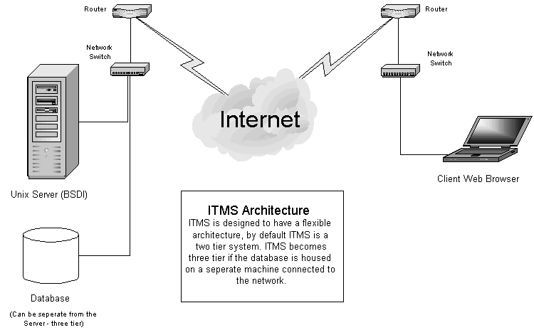

2.1.1 Two-tier architecture.
Under this implementation, the SQL server will be installed on the same machine as the Apache web-server. All SQL queries will be sent to the localhost and therefore will not require going over the network. Under this implementation, user posts to the database should be faster, thereby decreasing web server response time.

2.1.2 Three-tier architecture.
Under this implementation, the database will be stored on a separate machine other than the web server. All SQL queries will be directed to a machine name and logical port address. This schema may increase the latency of a CGI POST.
2.2 Client / Server Software Layers

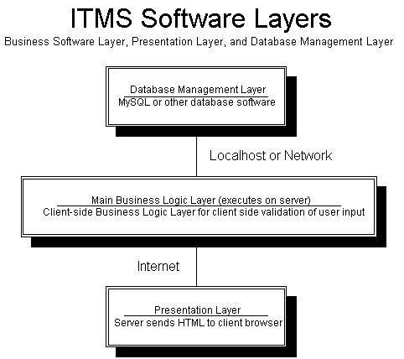

2.2.1 Presentation Layer.
This layer resides at the “edge” of the software system. It’s job is to capture external event requests and to perform some degree of editing of incoming data. It also is charged with presenting the event responses to the outside world (e.g. the screens and reports). This layer is usually allocated to the client machine or, in the case of a Web based
application, to the Web server. Note: What is included in this general description of the presentation layer is the graphical user interface (GUI).

2.2.2 "Business" Logic Layer.
This layer contains the code, which executes and enforces the policy of the business. The business rules are contained in the “business” logic layer, hence the name. This software layer may be deployed on the client machines, on the server, or any machine on the network.

2.2.3 Data Management Layer.
This layer provides access to the stored data. It manages concurrent requests to read and write to the database. In the case where data is distributed throughout the system, this layer would handle the synchronization of these distributed data elements. In almost all cases, this software layer is defined by the data base management system used.

3 SYSTEM INTERFACE DESIGN
The requirements that have been imposed on ITMS regarding the look and feel are clarified in the following subsections.

3.1 System Overview
ITMS is intended to automate some of the HR aspects of office management. Functions such as task delegation and tracking compose a bulk of what makes ITMS a useful system. ITMS should be applicable to any dynamic office environment where employees are not involved in a routine structure, but where tasks and jobs are changing or where employees are meeting with different clients.

3.2 Application Overview
ITMS is a dynamic web-based application with a database backend. Users can access ITMS without having to install any additional software onto a standard operating system. This is advantageous because it can be accessed from any computer with access to the Internet and can be used and updated in a moments notice. ITMS supports concurrent connections so that many users can be updating the database simultaneously and view the updates of each other almost instantly.

3.3 Window Navigation Diagram
ITMS is based on an intuitive Graphical User Interface (GUI) and can easily be navigated through a navigation menu that directs users to the different options that are offered through ITMS. Based upon User privilege level, certain functionality may or may not be available to users; this prevents unauthorized users from making global changes to the structure of ITMS. Only administrators of ITMS have permission to make changes to the Users that can access ITMS as well as manipulate the Tasking functions that the program is based upon.

3.4 Window Layout
All windows are browser based and therefore are viewable in the same manner as normal web pages. Dependant on certain computer resolution settings, the scrolling features that are offered in web browsers or wheel mice may need to be incorporated in order to view the whole web page at any time. The look and feel of ITMS is meant to reflect the Intranet environment of the Project Sponsor AHN. The following graphics illustrate the look and feel of ITMS:

The User Login Screen:

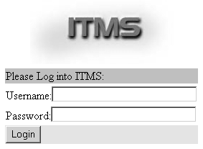

The Home Screen:

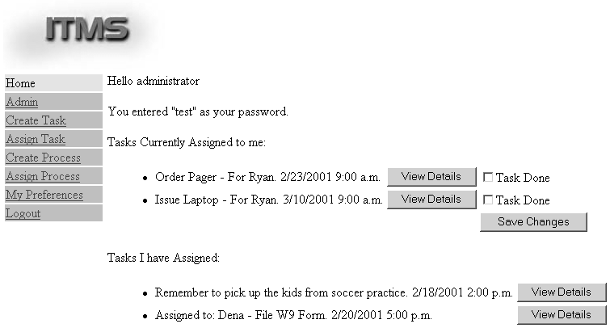

3.5 Window Specification
Windows must be organized in a manner as to allow the users of ITMS to navigate quickly through the system so that updates or modifications can be done without having to click more than 5 times from the login screen to get to any option offered by ITMS. Also screens should be organized in a manner to be optimally viewed at the resolution of 800x600 pixels.

3.6 Window Description
The navigation menu will be reachable regardless of where a User may be in ITMS at any time. The menu will be on the left side of the screen and go across from top down. Submenus will appear as links under the main navigation categories so that a User can jump to submenus without having to click an additional amount of times to get to a certain place in the program. A global footer will also appear at all times in the browser which will display any additional notes such as public licensing information.

3.7 Window Mini-Specification
A link which will say ITMS will be at the top left corner of the page which will bring users to the VDPG web-page upon activation.

3.8 Field Specification
All screens should be organized to allow sufficient number of characters to be displayed in each input field. In pages that allow input of a large amount of data at once time, such as the “Create New User” section, the format should be easily viewable at the screen resolution 800x600 pixels.

4 DATABASE DESIGN
This section provides the translation of the informational model contained in the Software
Requirements Specification (SRS) into a relational database. The relational database will be comprised of tables. Each table being a series of columns which represent individual data elements. The data records in the table form the rows. Each table has a primary key. Tables are related to each other by embedding the primary key from one table into another as a foreign key to implement the relationship. Foreign keys enable the relational database management system to enforce referential integrity. Referential integrity insures that no row in a" parent" table can be deleted if it is still referenced in a row of a "child" table.

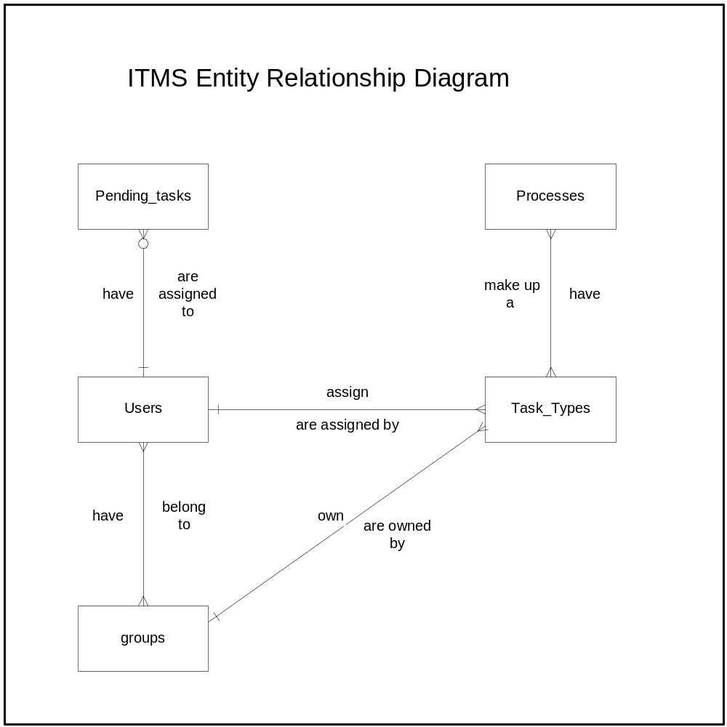

5 INTERNAL COMPONENT DESIGN
This section provides the detailed description for the design of the software. Included are
software processes, software interactions, and as applicable interaction and logic diagrams depicting the relationships of modules and functions required by the project. The purpose of this section is to provide sufficient detail about the software that would be
difficult to uncover by reading the code. This should be accomplished by identifying processes and illustrating processing dependencies, describing key algorithms and data structures within each process, and illustrating the message interaction between processes.

5.1 itms.css

5.1.1 Type
Logical Characteristics: Defines the general look and feel for every ITMS page
Physical Characteristics: CSS File (Cascading Style Sheet)

    - Purpose
To easily change the look and feel of ITMS in one file.

    - Function
Uses Cascading Style Sheets to provide ITMS a uniform look and feel.

5.1.4 Subordinates

5.1.5 Dependencies

5.1.6 Processing
All ITMS HTML code references this Cascading Style Sheet to provide ITMS pages a uniform look and feel.

    - Data

  - header

    - Type
Logical Characteristics: Included on every ITMS page to give ITMS a standard header text and/or images. Ensures that a valid user is logged in through login
Physical Characteristics: PHP files (.php extension) header, menu, and login

    - Purpose
To give ITMS a standard header, and to ensure the user is logged in and they are allowed to view the page.

    - Function
Gets user name and password, checks it against LDAP and mySQL. Ensures the user is allowed to view the requested data.

    - Subordinates
Every other ITMS module.

    - Dependencies
ldap_tools, db_tools.

    - Processing
Queries LDAP and the SQL database in order to retrieve characteristics about the user.

    - Data
User’s name, password, groupID, userID, isAdmin, isLoggedIn

5.3 footer

5.3.1 Type
Logical Characteristics: File to be included on the bottom of every ITMS page in order to have a standard message and/or look to the footer of ever ITMS page.
Physical Characteristics: PHP file (.php extension)

    - Purpose
Provides licensing information related to ITMS and anything else desired on the bottom of each ITMS page.

    - Function
Shows the user applicable copyright and licencing info.
    - Subordinates
none

    - Dependencies
none

    - Processing

5.3.7 Data

5.4 db_tools

5.4.1 Type
Logical Characteristics: ITMS file that defines the functions for communication with the Relational database.
Physical Characteristics: PHP file (.php extension)

    - Purpose
To provide a standard interface to any supported SQL database.

    - Function
Defines functions for connecting and disconnecting from the database, as well as modifying and retrieving data from the database.

    - Subordinates

5.4.5 Dependencies

5.4.6 Processing
Calls the equivalent function for the SQL database used.

    - Data
Database server info, username, password, and queries.

5.5 config

5.5.1 Type
Logical Characteristics: ITMS file that defines variables for where the DB is, the DB username and password, where the document root is, and many other system wide variables.
Physical Characteristics: PHP file (.php extension)

    - Purpose
To provide a standard interface for all modules to extract the configurable options.

    - Function
Defines variables that a system administrator would possibly need to modify in order for ITMS to run within a specific environment. If and when additional features are added to ITMS which require new global variables, they should be included in config.php

5.5.4 Subordinates

5.5.5 Dependencies

5.5.6 Processing
Values are assigned to global variables

    - Data

5.6 error_handler

5.6.1 Type
Logical Characteristics: ITMS file which handles and logs all possible error codes, conditions, and messages. Reports serious errors to the administrator via. syslog.
Physical Characteristics: PHP files (.php extension) error_codes, error_handler

    - Purpose
To report and track all customizable errors which occur while ITMS is running

    - Function
Handles and logs all possible errors which occur while ITMS runs

5.6.4 Subordinates

5.6.5 Dependencies

5.6.6 Processing
On error condition, appropriate action is taken.

    - Data
Error messages, codes, priority level.

5.7 reminder

5.7.1 Type
Logical Characteristics: ITMS file run by cron to send out task reminders.
Physical Characteristics: PHP file (.php extension)

    - Purpose
To remind users of their pending tasks

    - Function
Gets all pending tasks from the database that have exceeded their lag time, then sends out email reminder to the user responsible for completing the task.

5.7.4 Subordinates

5.7.5 Dependencies
db_tools

    - Processing
Queries Database for all pending tasks that have exceeded their lag time, then sends out email reminder to the user responsible for completing the task.

    - Data
Pending tasks, lag time, user email, user preferences.

5.8 myprefs

5.8.1 Type
Logical Characteristics: ITMS page for viewing/modifying the current user’s preferences, such as email address(es) and email preferences (HTML or plain text), and weekly days and times to receive reminders.
Physical Characteristics: PHP file (.php extension)

    - Purpose
To track a user’s preferred settings as related to email reminders.

    - Function
Provides the interface between the user’s preferences and user_preference table in the database.

5.8.4 Subordinates

5.8.5 Dependencies
db_tools

    - Processing
If the user wants to change his/her email preferences, ITMS will update the database to reflect these changes.

    - Data
HTML_email, digest/immediate reminders, Monday, Tuesday, Wednesday, Thursday, Friday, Saturday, Sunday, 6a.m., 10a.m., 2p.m. 6p.m.

5.9 task_mgt

5.9.1 Type
Logical Characteristics: ITMS Task Management Module, task_create creates a new task_type, such as order pager(generic), a task is a specific instance of a task-type, such as order new employee “Ryan” a pager.
Physical Characteristics: PHP files (.php extension), index, task_assign, task_assign2, task_create, task_edit, task_pending_edit.

    - Purpose
To handle all specific task management utilities, such as assign, or update a specific pending task, as well as create a new task type.

    - Function
Queries and updates the pending task table as necessary to manage pending tasks.

5.9.4 Subordinates

5.9.5 Dependencies
db_tools

    - Processing
Queries and updates the pending task table as necessary to manage pending tasks.

    - Data
User group, task info, and isAdmin.

5.10 process_mgt

5.10.1 Type
Logical Characteristics: ITMS Process Management Module, process is a collection of tasks that must be performed many times, such as hiring an employee.
Physical Characteristics: PHP files (.php extension) process, process_assign, process_assign2, process_assign3, process_create, process_edit.

    - Purpose
To handle all process management utilities, such as assign a process, edit a process, and create a process.

    - Function
Queries and updates the process table and the pending_tasks table to manage processes.

5.10.4 Subordinates

5.10.5 Dependencies
db_tools

    - Processing
Queries and updates the process table and the pending_tasks table to manage processes.

    - Data
User group, process, info, and isAdmin.

5.11 user_mgt

5.11.1 Type
Logical Characteristics: ITMS User Management Module, a user is any person who can assign or be assigned a task.
Physical Characteristics: PHP files (.php extension) user_mgt, user_edit, user_delete.

    - Purpose
To handle all user management utilities, such as add, edit, or delete a user.

    - Function
Queries and updates user and group tables as necessary to manage ITMS users.

5.11.4 Subordinates

5.11.5 Dependencies
db_tools, ldap_tools

    - Processing
Queries and updates user and group tables as necessary to manage ITMS users.

    - Data
IsAdmin, user info

5.12 group_mgt

5.12.1 Type
Logical Characteristics: ITMS Group Management Module, a group is a collection of users, groups are used to determine who a user can assign a task to.
Physical Characteristics: PHP files (.php extension) group_mgt, group_delete.

    - Purpose
To handle all group management utilities, such as add, edit, or delete a group.

    - Function
Queries and updates user and group tables as necessary to manage ITMS groups.

5.12.4 Subordinates

5.12.5 Dependencies
db_tools, ldap_tools

    - Processing
Queries and updates user and group tables as necessary to manage ITMS users.

5.12.7 Data
IsAdmin, user info

5.13 help

5.13.1 Type
Logical Characteristics: ITMS help page, contains help topics for all ITMS pages and explains how to use ITMS in general.
Physical Characteristics: PHP file (.php extension)

    - Purpose
To provide help on how to use ITMS, accessible form each ITMS page, or can give general and All ITMS help topics.

    - Function
If a page variable exists, the user is taken to that section of the user manual/help system. If the user is admin then they can see help about installing, configuring, and management of ITMS.

5.13.4 Subordinates

5.13.5 Dependencies

    - Processing
If a page variable exists, the user is taken to that section of the user manual/help system. If the user is admin then they can see help about installing, configuring, and management of ITMS.

    - Data
IsAdmin, current page.

5.14 logout

5.14.1 Type
Logical Characteristics: Used to log the user out of ITMS, cleans up all ITMS cookies and variables.
Physical Characteristics: PHP file (.php extension)

    - Purpose
To completely log the user out of ITMS so that the user must re-login to access ITMS, or to log user out of system after 10 minutes of inactivity.

    - Function
Cleans up all cookies and variables related to the ITMS user.

    - Subordinates

    - Dependencies
    - Processing
Delete cookies, username, group, and all other variables.
    - Data
Cookie names, user vars.
5.15 Add_users_to_ITMS
5.15.1 Type

Logical Characteristics: Used to add users to the ITMS database which already exist in the LDAP directory which is specified in the config.php file.
Physical Characteristics: PHP file (.php extension)

5.15.2 Purpose
To save time and to avoid repetitive and error prone manual entry of user names which are already in the LDAP directory.

5.15.3 Function
Creates users in the ITMS database.

5.15.4 Subordinates

    - Dependencies
    - Processing
Opens and reads usernames from the LDAP directory and inserts the usernames into the ITMS database.

5.15.7 Data
The LDAP directory server name and the root DN, the “bind as” from the config.php file.

6 PERFORMANCE ANALYSIS
Number of workstations supported depends on the Apache web server’s capacity for multiple TCP/IP connections. Simultaneous database access depends on MySQL User handling capabilities, however the software documentation suggests that multiple Users are supported in simultaneous queries.

Relative timing associated with I/O:

Results must appear within 5 seconds when Users are working within the Intranet
- Apache web server documentation denotes an expected response timeframe of 5 seconds for any CGI POST made to the web server through moderate local area network traffic.

Results must appear within 10 seconds when Users are working over the Internet
- Apache web server documentation also denotes an expected response timeframe of 10 seconds for any CGI POST made to the web server through moderate Internet traffic.

Querying attempts are dependent upon hardware and network traffic
- Even under extreme network traffic, all requests made to the Apache web server should be fulfilled within the required time specified by the Project Sponsor. ITMS is built with the assumption that the hosting web server has at least a 10Mbs Ethernet backbone to an Internet router.

Under normal circumstances the Apache web server should be able to handle a realistic number of concurrent connections and still fall within this time restraint.

7 FEASIBILITY AND RESOURCE ESTIMATES
This section should contain a summary of the computer resources required to build, operate and maintain the software. (See SRS Section 2.4)

Client:
IE 4+ or NS 4+
Cookies must be turned on, and JavaScript enabled
Connection to the internet/intranet (access to the Server described below)
Server:
Hard Drive Space: 200 MB
Ram: 64 MB
Operating System: BSDI 4.2
Domain name to be able to send SMTP based emails from
TCP/IP Network Connection:
Supporting Software:
PHP v.4
MySQL
LDAP
SSL
Web Server (recommend Apache)
8 SOFTWARE REQUIREMENTS TRACEABILITY MATRIX
The matrix relates the design components and the requirement elements by relating the paragraph numbers in this document to paragraph numbers in the Software Requirements
Specification Document. See Appendix B.

APPENDIX A: ITMS MODULE MAP
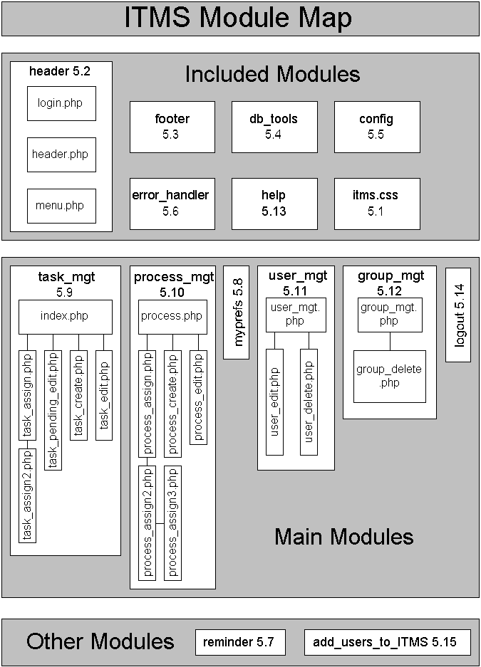
APPENDIX B: REQUIREMENTS TRACEABILITY MATRIX

Appendix C: Data Flow Diagram
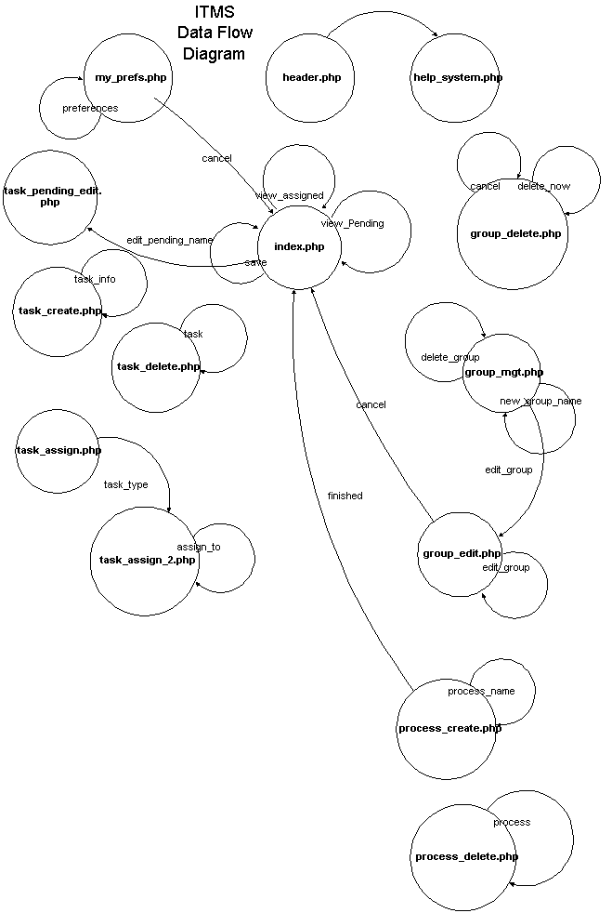
APPENDIX C: continued
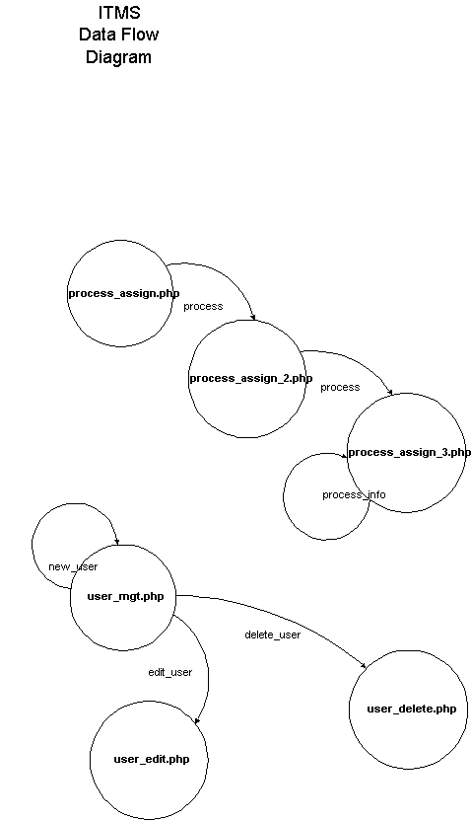
APPENDIX D: APPROVALS

Software Provider:
Organization Name: ValleyData Programming Group
Project Name (short title): ITMS
Project Name (full title): Internet Task Tracking System

As a software provider for Angus-Hamer, Inc., we agree to the scope and content of the requirements specified in the "Software Design Document" and agree that ValleyData Programming Group understands this document and will comply by its guidelines.

Provider___________________________________________________
Ryan Mahoney

Provider___________________________________________________
Aaron McBride

Provider___________________________________________________
Matthew Palmerlee

Provider___________________________________________________
Jaspreet Singh

Provider___________________________________________________
Charles Smothers

Provider___________________________________________________
Ted Ryon (CSUS Faculty Advisor)

Project Sponsor:
Organization Name: Angus-Hamer, Inc.
Contact Person’s Name: Corie Hamer
Title: Web Design and System Programming Specialist
Email Address: corie@angushamer.com

I authorize the individuals mentioned above to act as a designated software provider for Angus-Hamer, Inc. I have read the document entitled "Software Design Document", and agree that the requirements, as stated, provide all that is necessary for the development team to proceed with the design and implementation of the software system.

Contact_____________________________________________________
Corie Hamer

